Functions in C++
A function is a set of statements that takes input, does some specific computation, and produces output. The idea is to put some commonly or repeatedly done tasks together to make a function so that instead of writing the same code again and again for different inputs, we can call this function.
In simple terms, a function is a block of code that runs only when it is called.
Syntax:
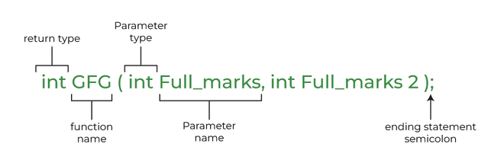
Syntax of Function
#include <iostream>
using namespace std;
int max(int x, int y)
{
if (x > y)
return x;
else
return y;
}
int main()
{
int a = 10, b = 20;

int m = max(a, b);

cout << "m is " << m;
return 0;
}

Why Do We Need Functions?
- Functions help us in reducing code redundancy. If functionality is performed at multiple places in software, then rather than writing the same code, again and again, we create a function and call it everywhere. This also helps in maintenance as we have to make changes in only one place if we make changes to the functionality in future.
- Functions make code modular. Consider a big file having many lines of code. It becomes really simple to read and use the code, if the code is divided into functions.
- Functions provide abstraction. For example, we can use library functions without worrying about their internal work.

Function Declaration

A function declaration tells the compiler about the number of parameters, data types of parameters, and returns type of function. Writing parameter names in the function declaration is optional but it is necessary to put them in the definition. Below is an example of function declarations. (parameter names are not present in the below declarations)
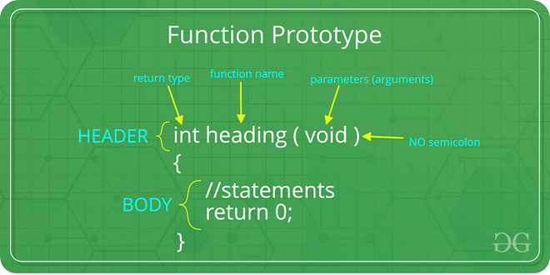

Types of Functions
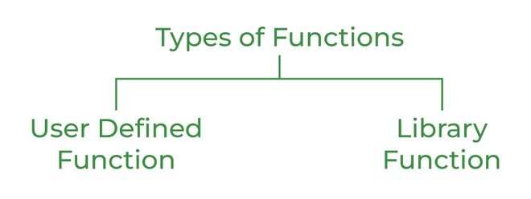

User Defined Function
User-defined functions are user/customer-defined blocks of code specially customized to reduce the complexity of big programs. They are also commonly known as “tailor-made functions” which are built only to satisfy the condition in which the user is facing issues meanwhile reducing the complexity of the whole program.

Library Function
Library functions are also called “built-in Functions“. These functions are part of a compiler package that is already defined and consists of a special function with special and different meanings. Built-in Function gives us an edge as we can directly use them without defining them whereas in the user-defined function we have to declare and define a function before using them.
For Example: sqrt(), setw(), strcat(), etc.

Parameter Passing to Functions
The parameters passed to the function are called actual parameters. For example, in the program below, 5 and 10 are actual parameters.
The parameters received by the function are called formal parameters. For example, in the above program x and y are formal parameters.
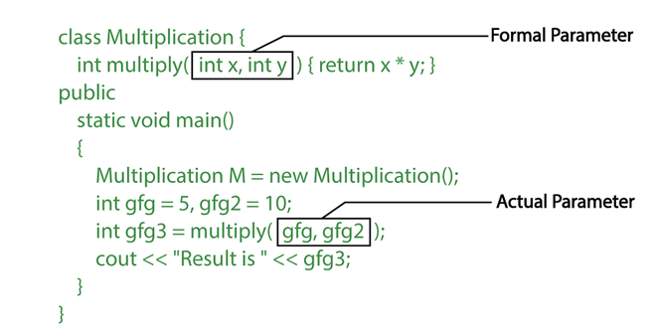
There are two most popular ways to pass parameters:

- Pass by Value: In this parameter passing method, values of actual parameters are copied to the function’s formal parameters. The actual and formal parameters are stored in different memory locations so any changes made in the functions are not reflected in the actual parameters of the caller.
- Pass by Reference: Both actual and formal parameters refer to the same locations, so any changes made inside the function are reflected in the actual parameters of the caller.

Function Definition
Pass by value is used where the value of x is not modified using the function fun().

// C++ Program to demonstrate function definition
#include <iostream>
using namespace std;

void fun(int x)
{
// definition of
// function
x = 30;
}

int main()
{
int x = 20;
fun(x);
cout << "x = " << x;
return 0;
}

Functions Using Pointers
The function fun() expects a pointer ptr to an integer (or an address of an integer). It modifies the value at the address ptr. The dereference operator * is used to access the value at an address. In the statement ‘*ptr = 30’, the value at address ptr is changed to 30. The address operator & is used to get the address of a variable of any data type. In the function call statement ‘fun(&x)’, the address of x is passed so that x can be modified using its address.
- C++
// C++ Program to demonstrate working of
// function using pointers
#include <iostream>
using namespace std;

void fun(int* ptr)
{ *ptr = 30; }

int main()
{
int x = 20;
fun(&x);
cout << "x = " << x;

return 0;
}

Difference between call by value and call by reference in C++
Call by value | Call by reference
A copy of the value is passed to the function | An address of value is passed to the function
Changes made inside the function are not  reflected on other functions | Changes made inside the function are reflected  outside the function as well
Actual and formal arguments will be created at  different memory location | Actual and formal arguments will be created at  same memory location.

C++ Passing Array to Function
In C++, to reuse the array logic, we can create a function. To pass an array to a function in C++, we need to provide only the array name.
function_name(array_name[]); //passing array to function

Example: Print the minimum number in the given array.
#include <iostream>
using namespace std;
void printMin(int arr[5]);
int main()
{
int ar[5] = { 30, 10, 20, 40, 50 };
printMin(ar); // passing array to function
}
void printMin(int arr[5])
{
int min = arr[0];
for (int i = 0; i < 5; i++) {
if (min > arr[i]) {
min = arr[i];
}
}
cout << "Minimum element is: " << min << "\n";
}

Parameter Passing Techniques in C/C++
There are different ways in which parameter data can be passed into and out of methods and functions. Let us assume that a function B() is called from another function A(). In this case, A is called the “caller function” and B is called the “called function or callee function”. Also, the arguments which A sends to B are called actual arguments and the parameters of B are called formal arguments.

Terminology's:
- Formal Parameter: A variable and its type as they appear in the prototype of the function or method.
- Actual Parameter: The variable or expression corresponding to a formal parameter that appears in the function or method call in the calling environment.
- Modes:
  - IN: Passes info from caller to the callee.
  - OUT: Callee writes values in the caller.
  - IN/OUT: The caller tells the callee the value of the variable, which may be updated by the callee.
Important Methods of Parameter Passing are as follows:

1. Pass By Value
This method uses in-mode semantics. Changes made to formal parameters do not get transmitted back to the caller. Any modifications to the formal parameter variable inside the called function or method affect only the separate storage location and will not be reflected in the actual parameter in the calling environment. This method is also called call by value.
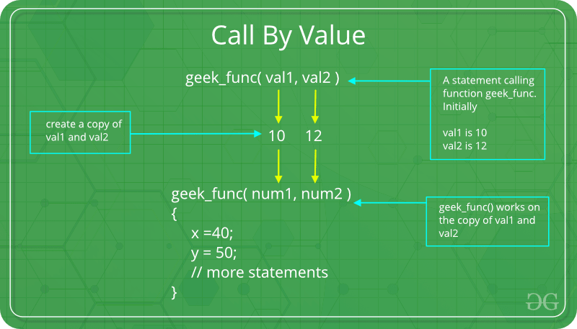

Example of Pass by Value
- C
- C++
// C program to illustrate
// call by value
#include <stdio.h>

void func(int a, int b)
{
a += b;
printf("In func, a = %d b = %d\n", a, b);
}
int main(void)
{
int x = 5, y = 7;

// Passing parameters
func(x, y);
printf("In main, x = %d y = %d\n", x, y);
return 0;
}
Output
In func, a = 12 b = 7
In main, x = 5 y = 7

Shortcomings of Pass By Value:
- Inefficiency in storage allocation
- For objects and arrays, the copy semantics are costly

2. Pass by reference(aliasing)
This technique uses in/out-mode semantics. Changes made to formal parameter do get transmitted back to the caller through parameter passing. Any changes to the formal parameter are reflected in the actual parameter in the calling environment as formal parameter receives a reference (or pointer) to the actual data. This method is also called as call by reference. This method is efficient in both time and space.
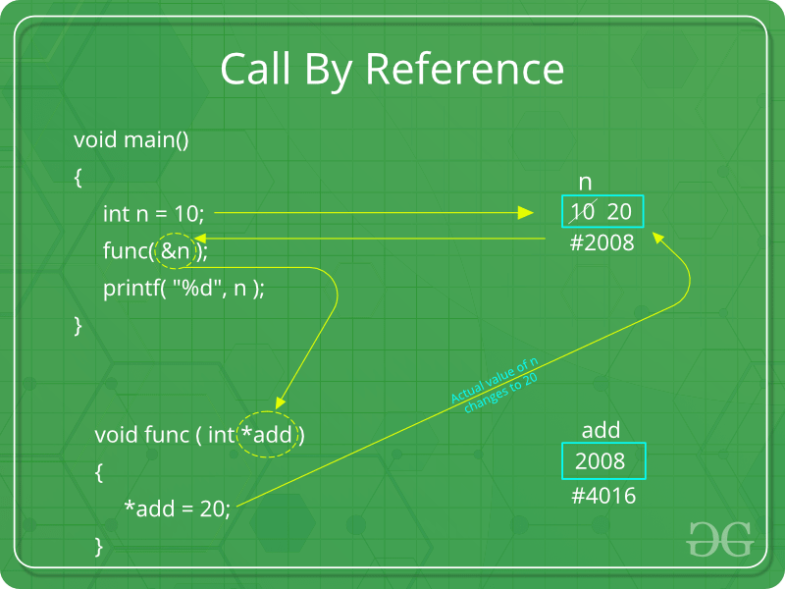

Example
- C
- C++
// C program to illustrate
// call by reference
#include <stdio.h>

void swapnum(int* i, int* j)
{
int temp = *i;
*i = *j;
*j = temp;
}

int main(void)
{
int a = 10, b = 20;

// passing parameters
swapnum(&a, &b);

printf("a is %d and b is %d\n", a, b);
return 0;
}
Output
a is 20 and b is 10

Shortcomings of Pass by Reference
- Many potential scenarios can occur
- Programs are difficult to understand sometimes

Other Methods of Parameter Passing
These techniques are older and were used in earlier programming languages like Pascal, Algol, and Fortran. These techniques are not applicable in high-level languages.

1. Pass by Result
This method uses out-mode semantics. Just before control is transferred back to the caller, the value of the formal parameter is transmitted back to the actual parameter. This method is sometimes called call by the result. In general, the pass-by-result technique is implemented by copying.

2. Pass by Value-Result
This method uses in/out-mode semantics. It is a combination of Pass-by-Value and Pass-by-Result. Just before the control is transferred back to the caller, the value of the formal parameter is transmitted back to the actual parameter. This method is sometimes called call by value-result.

3. Pass by Name
This technique is used in programming languages such as Algol. In this technique, the symbolic “name” of a variable is passed, which allows it both to be accessed and updated.
Example
To double the value of C[j], you can pass its name (not its value) into the following procedure.
procedure double(x);
real x;
begin
x:=x*2
end;
In general, the effect of pass-by-name is to textually substitute the argument in a procedure call for the corresponding parameter in the body of the procedure. Implications of Pass-by-Name mechanism:
- The argument expression is re-evaluated each time the formal parameter is passed.
- The procedure can change the values of variables used in the argument expression and hence change the expression’s value.

